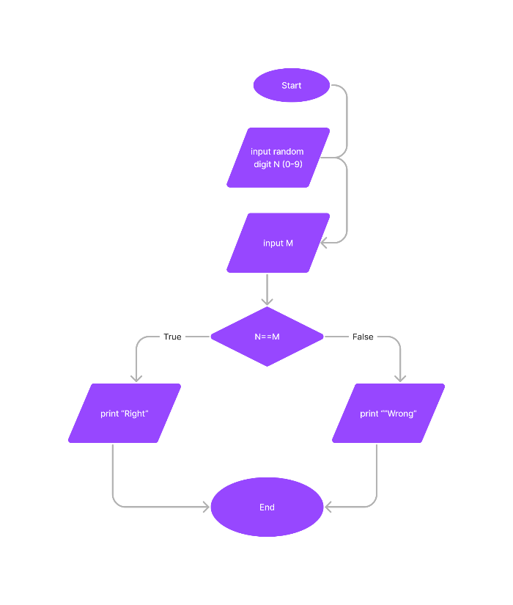Begin

Random N (0-9)

Input M

If (N==M)

Print “Right”

Else

Print “False”

End